

CSA0501-DATABASE MANAGEMENT SYSTEMS

LAB EXPERIMENTS DATE: 12/08/2026

EXPERIMENT 19– TRIGGER

AIM: To implement a trigger in MySQL.

PROCEDURE:
- Select the pet_management database.
- Display the existing records from the pet_details table.
- Create an audit table to store the old values.
- Create a BEFORE UPDATE trigger on the pet_details table.
- Update a pet record to activate the trigger.
- Display the audit table and verify the recorded changes.

PROGRAM:

1. Display existing records

SELECT * FROM pet_details;

2. Create Audit Table

CREATE TABLE pet_details_audit (

sno INT,

pet_name VARCHAR(50),

pet_breed VARCHAR(50),

age VARCHAR(30),

food VARCHAR(50),

place VARCHAR(50),

total INT,

changed_at TIMESTAMP DEFAULT CURRENT_TIMESTAMP

);

3. Create BEFORE UPDATE Trigger

DELIMITER //

CREATE TRIGGER pet_before_update

BEFORE UPDATE ON pet_details

FOR EACH ROW

BEGIN

INSERT INTO pet_details_audit

(sno, pet_name, pet_breed, age, food, place, total)

VALUES

(OLD.sno, OLD.pet_name, OLD.pet_breed, OLD.age,

OLD.food, OLD.place, OLD.total);

END //

DELIMITER ;

4. Update a Record

For example, change the food of the pet whose sno is 1:

UPDATE pet_details

SET food = 'Rice'

WHERE sno = 1;

5. Display Audit Table

SELECT * FROM pet_details_audit;

OUTPUT:
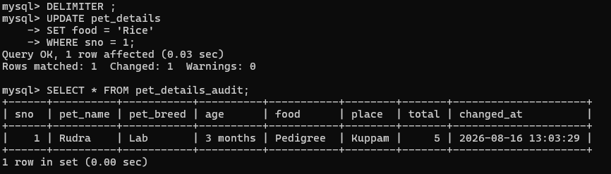

RESULT: The BEFORE UPDATE trigger was successfully created and executed. The old pet details were automatically stored in the audit table when the record was updated..

